**Supplementary Materials**

**Data availability**

The datasets are available at the Nigeria Hydrological Services Agency (NIHSA) by an official application to the director.

Office: Foundation Plaza, Plot 22 Shettma Ali Monguno Crescent, Utako, Abuja, FCT, Nigeria.

eMail: nihsa.gov.ng

3.2.1 Interpolation Implementation

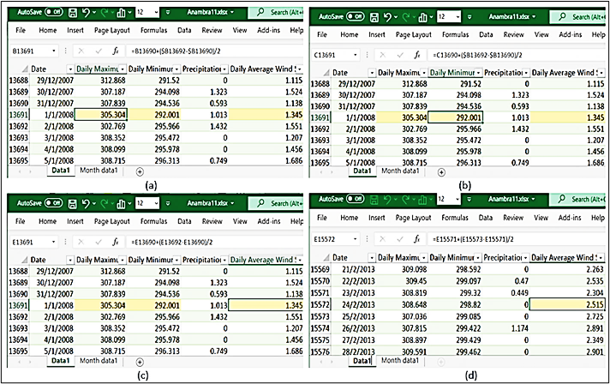

3.2.2 The algorithm procedure for the validity evaluation

|  |
| --- |
| **Pseudocode:** |
| **Start** |
| **1. Set ${\vec{μ}}_{I},{\vec{μ}}_{2},…, {\vec{μ}}_{K} as separate$**  arbitrarily selected inputs between ${\vec{μ}}_{1 },{\vec{μ}}_{2},…, {\vec{μ}}_{n}, k=n=4$ **2. Iterate given $i to represents 1 ,2,…, n$** *//***affix ${\vec{x}}_{1 },{\vec{x}}_{2 },…, {\vec{x}}_{n}$****update $γ$**  **3.**  **Stop**  **4. Iterate given $j=1 ,2, …, k$**  *//***affix $γ,$**  **reform ${\vec{x}}_{1 },{\vec{x}}_{2 },…, {\vec{x}}_{n}$ ${ \vec{μ}}_{j}=\frac{1}{n_{j}}\sum_{i=1}^{n}{{ γ}_{ij}}{\vec{x}}_{i}$**  *// ${\vec{μ}}_{n}$*is the set to the average of all pointsassigned to group j  **5. Iterate until convergence, stop procedure**  **Else**  **repeat ${\vec{μ}}_{I},{\vec{μ}}_{2},…, {\vec{μ}}_{K}$** |
| **End** |

The algorithm pseudocode

3.3.3 Computation of persistence homology (PH) in the TDA-ML approach

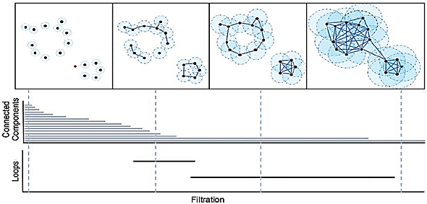

Filteration and corresponding Barcodes

**4.1. K-mean Clustering of the Hybrid Method**



Predicted Flooding States in Nigeria

Cluster Validity Tests Results for Dunn and Silouette Indices

|  |  |  |
| --- | --- | --- |
| State | Dunn index | Silhouette index |
| Anambra | 0.8123 | 0.8619 |
| Bayelsa | 0.7913 | 0.8758 |
| Benue | 0.3391 | 0.3794 |
| Edo | 0.6357 | 0.6810 |
| Kogi | 0.5879 | 0.6118 |
| Kwara  River | 0.3529  0.8112 | 0.3804  0.9117 |

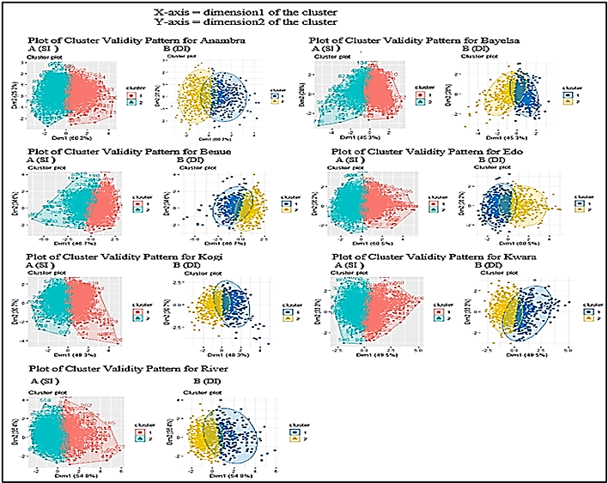

Plots of the Cluster, k = 2 Validity Feature Pattern for the Seven States

Table 5. Summary Statistics of Topological Features for Dimension 0 on September

|  |  |  |
| --- | --- | --- |
| State | Sum of all lifetimes $\left({sum}_{D}\right)$ | Avg. of lifetime of all holes $\left({avg}_{D}\right)$ |
| Anambra | 565.0383 | 19.4841 |
| Bayelsa | 552.9779 | 23.0408 |
| Benue | 562.8185 | 26.8009 |
| Edo | 563.3173 | 25.6053 |
| Kogi | 597.2725 | 29.8637 |
| Kwara | 629.9208 | 26.2467 |
| River | 566.9522 | 25.7705 |

Table 6. Summary Statistics of Topological Features for Dimension 1 on September

|  |  |  |  |  |
| --- | --- | --- | --- | --- |
| State | Max. holes lifetime ${(max}_{D})$ | Max. death point of holes ( $\max_{d})$ | Sum of all lifetimes $\left({sum}_{D}\right)$ | Avg. of lifetime of all holes $\left({avg}_{D}\right)$ |
| Anambra | 0.2343 | 21.3577 | 0.5986 | 0.4982 |
| Bayelsa | 0.4142 | 1.4142 | 2.0710 | 0.4142 |
| Benue | 0.3377 | 19.416 | 0.3387 | 0.3377 |
| Edo | 0.4142 | 15.414 | 1.6568 | 0.4442 |
| Kogi | 0.3377 | 1.4142 | 1.2726 | 0.4150 |
| Kwara | 0.4146 | 3.4112 | 1.0913 | 0.4143 |
| River | 0.4244 | 3.6070 | 0.7066 | 0.3027 |

**4.4. Classification of the Hydrological Areas**

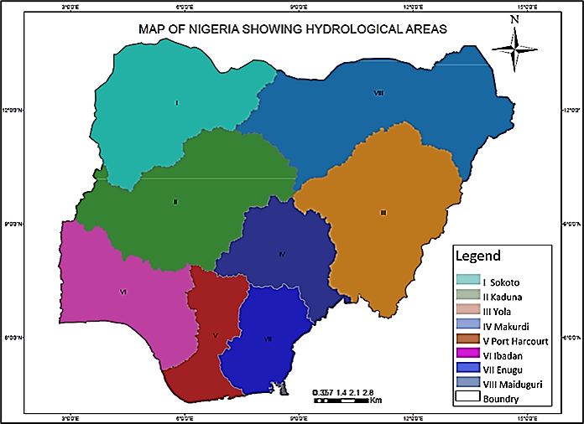

Map of Nigeria Showing Hydrological Areas

APPENDIX: Code for Data Presentation

import matplotlib.pyplot as plt

from matplotlib import style

style.use('ggplot')

import numpy as np

from sklearn.cluster import KMeans

from sklearn.cluster import MeanShift

import pandas as pd

from sklearn.preprocessing import scale

import sklearn.metrics as sm

import time

from sklearn.metrics import accuracy_score

from sklearn.metrics import confusion_matrix, classification_report

from sklearn.metrics import recall_score

from sklearn.preprocessing import StandardScaler

from sklearn.decomposition import PCA

from sklearn import preprocessing

data = pd.read_csv('Anambra11_Use_CLustered.csv')# reads the csv file

names = ['Date', 'Month Number','Monthly Maximum Temperature(K)', 'Monthly Minimum Temperature(K)', 'Precipitation (mm)', 'Monthly Average Wind Speed (m/s)', 'Clusters']#defines columns in the dataset

ax = plt.gca()

#data.hist()

data.plot(kind='density', subplots=True, layout=(3,3), sharex=False)

#data.plot(kind='box', subplots=True, layout=(3,3), sharex=False, sharey=False)

#plt.show()

#print((data.shape))

#print(data.Clusters.value_counts())

#plt.legend(loc='lower center', bbox_to_anchor=(0.5, 1.0),

# ncol=3, fancybox=True, shadow=True)

# plt.grid(True)#removes grid lines from plots

ax.xaxis.grid()

plt.axis('on')

ax = plt.gca()#activates the use of ax-set_facecolor

ax.set_facecolor('white')

#code segment to enable borders

for pos in ['top', 'bottom', 'right', 'left']:

ax.spines[pos].set_edgecolor('black')

Code For K-Means Clustering and Silhouette Analysis

import numpy as np

import pandas as pd

from sklearn.cluster import KMeans

from sklearn.metrics import silhouette_samples, silhouette_score

import matplotlib.pyplot as plt

import matplotlib.cm as cm

import seaborn as sns

print(__doc__)

input_data = pd.read_csv('Anambra11_Use.csv')

x = input_data.iloc[:,].values

#x = dataset.iloc[:,].values

for n_clusters in range(2,11):

# Create a subplot with 1 row and 2 columns

fig, (ax1, ax2) = plt.subplots(1, 2)

fig.set_size_inches(18, 7)

# The 1st subplot is the silhouette plot

# The silhouette coefficient can range from -1, 1 but in this example all

# lie within [-0.1, 1]

ax1.set_xlim([-0.1, 1])

# The (n_clusters+1)*10 is for inserting blank space between silhouette

# plots of individual clusters, to demarcate them clearly.

ax1.set_ylim([0, len(x) + (n_clusters + 1) * 10])

# Initialize the clusterer with n_clusters value and a random generator

# seed of 10 for reproducibility.

clusterer = KMeans(n_clusters=n_clusters, random_state=10 )

cluster_labels = clusterer.fit_predict(x)

# The silhouette_score gives the average value for all the samples.

# This gives a perspective into the density and separation of the formed

# clusters

silhouette_avg = silhouette_score(x, cluster_labels)

print("For n_clusters =", n_clusters,

"The average silhouette_score is :", silhouette_avg)

# Compute the silhouette scores for each sample

sample_silhouette_values = silhouette_samples(x, cluster_labels)

y_lower = 10

for i in range(n_clusters):

# Aggregate the silhouette scores for samples belonging to

# cluster i, and sort them

ith_cluster_silhouette_values = \

sample_silhouette_values[cluster_labels == i]

ith_cluster_silhouette_values.sort()

size_cluster_i = ith_cluster_silhouette_values.shape[0]

y_upper = y_lower + size_cluster_i

color = cm.nipy_spectral(float(i) / n_clusters)

ax1.fill_betweenx(np.arange(y_lower, y_upper),

0, ith_cluster_silhouette_values,

facecolor=color, edgecolor=color, alpha=0.7)

# Label the silhouette plots with their cluster numbers at the middle

# ax1.text(-0.05, y_lower + 0.5 * size_cluster_i, str(i))

# Compute the new y_lower for next plot

y_lower = y_upper + 10 # 10 for the 0 samples

ax1.set_title("The silhouette plot for the various clusters.")

ax1.set_xlabel("The silhouette coefficient values")

ax1.set_ylabel("Cluster label")

# The vertical line for average silhouette score of all the values

ax1.axvline(x=silhouette_avg, color="red", linestyle="--")

ax1.set_yticks([]) # Clear the yaxis labels / ticks

ax1.set_xticks([-0.1, 0, 0.2, 0.4, 0.6, 0.8, 1])

# 2nd Plot showing the actual clusters formed

colors = cm.nipy_spectral(cluster_labels.astype(float) / n_clusters)

ax2.scatter(x[:, 0], x[:, 1], marker='.', s=100, lw=0, alpha=0.7,

c=colors, edgecolor='k')

# Labeling the clusters

# centers = clusterer.cluster_centers_

# # Draw white circles at cluster centers

# ax2.scatter(centers[:, 0], centers[:, 1], marker='*',

# c="red",label='cluster 1', alpha=1, s=200,edgecolor='k')

#

# for i, c in enumerate(centers):

# ax2.scatter(c[0], c[1], marker='$%d$' % i, alpha=1,

# s=50, edgecolor='k')

ax2.set_title("The visualization of the clustered data")

# ax2.set_xlabel("Feature space for the 1st feature")

# ax2.set_ylabel("Feature space for the 2nd feature")

plt.suptitle(("Silhouette analysis for KMeans clustering on sample data "

"with n_clusters = %d" % n_clusters),

fontsize=14, fontweight='bold')

plt.show()

Code for persistent homology Coding Persistent Homology (Adamawa Jan1970)

1) call library for Topological Data Analysis **Jan1970**

library(TDA)

2) import Data(depend on location of the data)

ada=read.csv(file.choose())

View(ada)

3) Fix maximum filtration value (DiagLim <- 700) and maximum dimension for features (maxdimension <- 1) : means for 0-dimensional and 1-dimensional features.

DiagLim <- 700

maxdimension <-1

4) Apply persistent homology using Rips complex

ada1970 <- ripsDiag(ada,maxdimension,DiagLim,printProgress = TRUE)

5) Plot Barcode and Persistent Diagram (PD)

plot(ada1970[["diagram"]],barcode=TRUE,main="Barcode Adamawa Jan 1970")

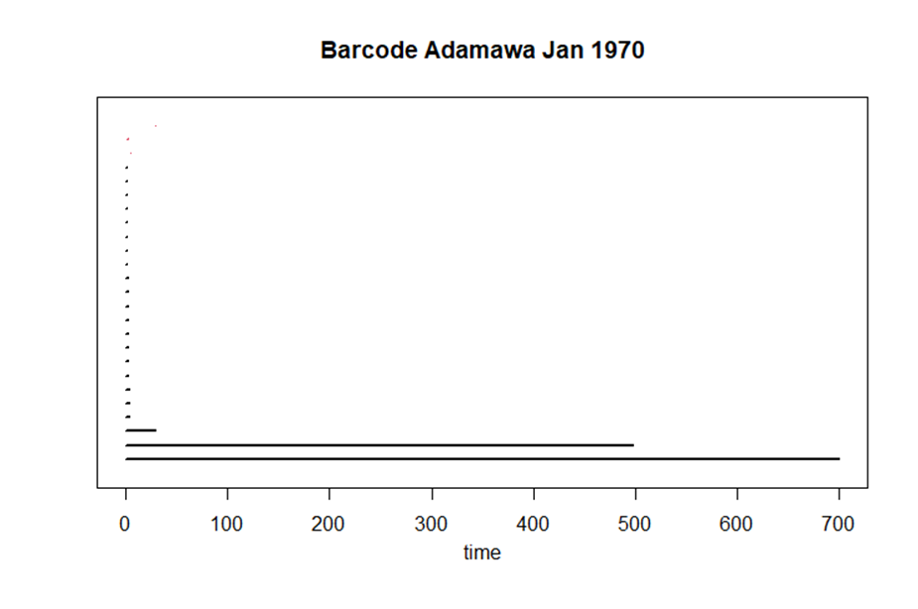

plot(ada1970[["diagram"]],main="PD Adamawa Jan 1970") 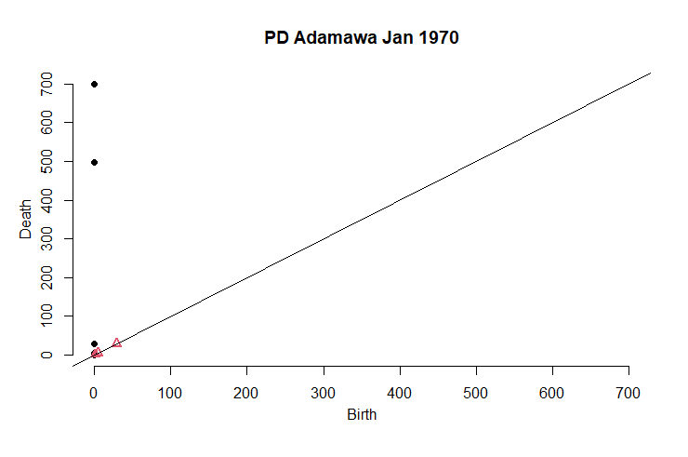

6) Now calculate summary statistic of topological features sum, average, maximum lifetime and maximum death point

7) save ada1970 as matrix

matrixada1970=as.data.frame.matrix(ada1970[["diagram"]])

Example :

> matrixada1970

dimension Birth Death

1 0 0.000000 700.000000

2 0 0.000000 497.116687

3 0 0.000000 28.879058

4 0 0.000000 3.464102

5 0 0.000000 3.162278

6 0 0.000000 3.162278

7 0 0.000000 2.449490

8 0 0.000000 2.449490

9 0 0.000000 2.449490

10 0 0.000000 2.236068

11 0 0.000000 2.236068

12 0 0.000000 2.236068

13 0 0.000000 2.000000

14 0 0.000000 1.732051

15 0 0.000000 1.414214

16 0 0.000000 1.414214

17 0 0.000000 1.000000

18 0 0.000000 1.000000

19 0 0.000000 1.000000

20 0 0.000000 1.000000

21 0 0.000000 1.000000

22 0 0.000000 1.000000

23 1 4.242641 4.898979

24 1 1.414214 1.732051

25 1 28.948230 29.017236

**calculate topological features for dimension=0 (connected component)**

1) First separate matrixada1970 for dimension 0 only

a=matrixada1970$dimension==0

ada1970dim0=matrixada1970[a,]

2) Second calculate lifetime of all features. Here lifetime mean the

difference between death and birth points.

ada1970dim0$difference=ada1970dim0$Death-ada1970dim0$Birth

>ada1970dim0

dimension Birth Death difference

1 0 0 700.000000 700.000000

2 0 0 497.116687 497.116687

3 0 0 28.879058 28.879058

4 0 0 3.464102 3.464102

5 0 0 3.162278 3.162278

6 0 0 3.162278 3.162278

7 0 0 2.449490 2.449490

8 0 0 2.449490 2.449490

9 0 0 2.449490 2.449490

10 0 0 2.236068 2.236068

11 0 0 2.236068 2.236068

12 0 0 2.236068 2.236068

13 0 0 2.000000 2.000000

14 0 0 1.732051 1.732051

15 0 0 1.414214 1.414214

16 0 0 1.414214 1.414214

17 0 0 1.000000 1.000000

18 0 0 1.000000 1.000000

19 0 0 1.000000 1.000000

20 0 0 1.000000 1.000000

21 0 0 1.000000 1.000000

22 0 0 1.000000 1.000000

3) Third, calculate the topological features.

4) For dimension 0, we don’t consider feature with death point = 700 since it is the higher dimensional complex. All data will have one higher dimensional complex and we omit this features.

>sum(ada1970dim0$difference)-DiagLim

[1] 562.4016

> avg=(sum(ada1970dim0$difference)-DiagLim)/(nrow(ada1970dim0)-1)

>avg

[1] 26.78103

**calculate topological features for dimension=1 (holes)**

1) First separate matrixada1970 for dimension 1 only

b=matrixada1970$dimension==1

ada1970dim1=matrixada1970[b,]

2) Second calculate lifetime of all features. Here lifetime mean the

difference between death and birth points.

ada1970dim1$difference=ada1970dim1$Death-ada1970dim1$Birth

> ada1970dim1

dimension Birth Death difference

31 1 1.2893 1.52370 0.234333

32 1 21.1459 21.3577 0.211765

33 1 0.9843 1.13690 0.152519

3) Third, calculate the topological features.

>sum(ada1970dim1$difference)

[1] 1.043183

>avg=sum(ada1970dim1$difference)/nrow(ada1970dim1)

>avg

[1] 0.3477275

>max(ada1970dim1$difference)

[1] 0.6563388

>max(ada1970dim1$Death)

[1] 29.01724

Notes: Repeat all step to calculate topological features for Sept1970.

#####################################################################

**for Adamawa Sept1970**

1) call library for Topological Data Analysis **Sept1970**

library(TDA)

2) import Data(depend on location of the data)

adam=read.csv(file.choose())

View(adam)

3) Fix maximum filtration value (DiagLim <- 700) and maximum dimension for features (maxdimension <- 1) : means for 0-dimensional and 1-dimensional features.

DiagLim <- 700

maxdimension <-1

4) Apply persistent homology using Rips complex

adam1970 <- ripsDiag(adam,maxdimension,DiagLim,printProgress = TRUE)

5) Plot Barcode and Persistent Diagram (PD)

plot(adam1970[["diagram"]],barcode=TRUE,main="Barcode Adamawa Sept 1970")

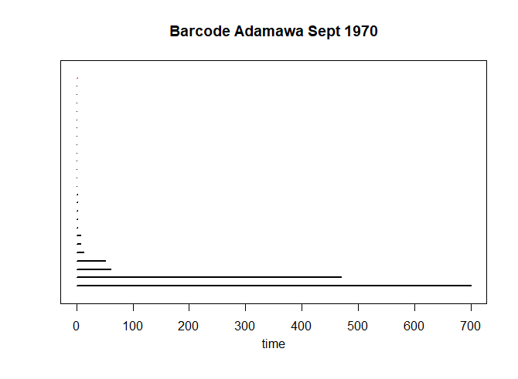

plot(adam1970[["diagram"]],main="PD Adamawa Sept 1970") 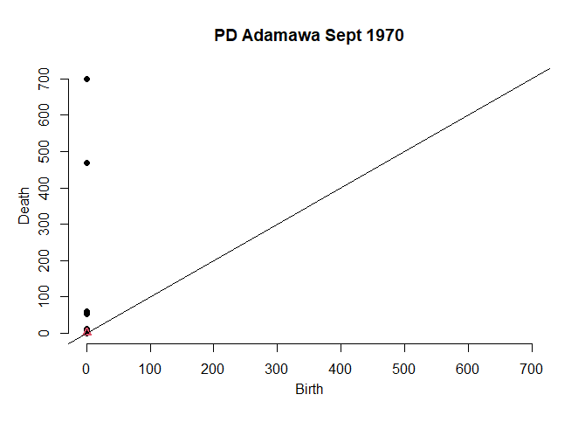

6) Now calculate summary statistic of topological features sum, average, maximum lifetime and maximum death point

7) save adam1970 as matrix

matrixadam1970=as.data.frame.matrix(adam1970[["diagram"]])

Example :

> matrixadam1970

dimension Birth Death

1 0 0 700.000000

2 0 0 469.171610

3 0 0 61.040970

4 0 0 51.874849

5 0 0 12.727922

6 0 0 7.141428

7 0 0 7.071068

8 0 0 2.236068

9 0 0 1.414214

10 0 0 1.414214

11 0 0 1.414214

12 0 0 1.414214

13 0 0 1.000000

14 0 0 1.000000

15 0 0 1.000000

16 0 0 1.000000

17 0 0 1.000000

18 0 0 1.000000

19 0 0 1.000000

20 0 0 1.000000

21 0 0 1.000000

22 0 0 1.000000

23 0 0 1.000000

24 0 0 1.000000

25 0 0 1.000000

26 1 1 1.414214

**calculate topological features for dimension=0 (connected component)**

1) First separate matrixadam1970 for dimension 0 only

a=matrixadam1970$dimension==0

adam1970dim0=matrixadam1970[a,]

2) Second calculate lifetime of all features. Here lifetime mean the

difference between death and birth points.

adam1970dim0$difference=adam1970dim0$Death-adam1970dim0$Birth

>adam1970dim0

dimension Birth Death difference

1 0 0 700.000000 700.000000

2 0 0 469.171610 469.171610

3 0 0 61.040970 61.040970

4 0 0 51.874849 51.874849

5 0 0 12.727922 12.727922

6 0 0 7.141428 7.141428

7 0 0 7.071068 7.071068

8 0 0 2.236068 2.236068

9 0 0 1.414214 1.414214

10 0 0 1.414214 1.414214

11 0 0 1.414214 1.414214

12 0 0 1.414214 1.414214

13 0 0 1.000000 1.000000

14 0 0 1.000000 1.000000

15 0 0 1.000000 1.000000

16 0 0 1.000000 1.000000

17 0 0 1.000000 1.000000

18 0 0 1.000000 1.000000

19 0 0 1.000000 1.000000

20 0 0 1.000000 1.000000

21 0 0 1.000000 1.000000

22 0 0 1.000000 1.000000

23 0 0 1.000000 1.000000

24 0 0 1.000000 1.000000

25 0 0 1.000000 1.000000

3) Third, calculate the topological features.

4) For dimension 0, we don’t consider feature with death point = 700 since it is the higher dimensional complex. All data will have one higher dimensional complex and we omit this features.

>sum(adam1970dim0$difference)-DiagLim

[1] 629.9208

> avg=(sum(adam1970dim0$difference)-DiagLim)/(nrow(adam1970dim0)-1)

>avg

[1] 26.2467

**calculate topological features for dimension=1 (holes)**

1) First separate matrixadam1970 for dimension 1 only

b=matrixadam1970$dimension==1

adam1970dim1=matrixadam1970[b,]

2) Second calculate lifetime of all features. Here lifetime mean the

difference between death and birth points.

adam1970dim1$difference=adam1970dim1$Death-adam1970dim1$Birth

> adam1970dim1

dimension Birth Death difference

26 1 1 1.414214 0.4142136

3) Third, calculate the topological features.

>sum(adam1970dim1$difference)

[1] 0.4142136

>avg=sum(adam1970dim1$difference)/nrow(adam1970dim1)

>avg

[1] 0.4142136

>max(adam1970dim1$difference)

[1] 0.4142136

>max(adam1970dim1$Death)

[1] 29.01724